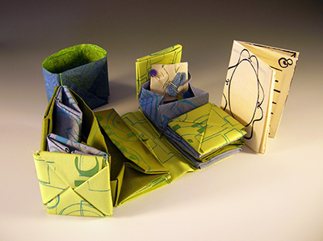

BOOK ARTS GUILD OF VERMONT PRESENTS

CHINESE SEWING BOX BOOK

A one day workshop with guest artist

ERIN SWEENEY
Chatelaines by Erin Sweeney, 2012.
A book structure created by the amazing Hedi Kyle - made entirely of folded boxes and enclosures based on paper wallets, and used to store sewing supplies - an origami lovers’ dream! Many things can be housed in this finished structure: surprises, stories, drawings, and prints. Students will leave with one finished book, a pattern to make another, and hopefully the start of a second book!
ERIN SWEENEY lives and works in southern New Hampshire, where she runs Lovely In The Home Press, and teaches Book Arts and Letterpress printing at the New Hampshire Institute of Art. erinsweeney.net
Saturday, March 26, 2016
10:00am - 3:00 pm
Ridgewood Clubhouse, South Burlington
Cost: $75, includes materials (Payment due in full with registration to reserve a spot)

Bottom of Form
Top of Form
Bottom of Form
Please send your completed registration form with a check made out to Book Arts Guild of Vermont, to:

Chinese Sewing Box Workshop
c/o Marcia Vogler
1510 Hinesburg Road
Charlotte, VT 05445

Spots in the workshop will be filled in the order in which the applications are received. You will receive confirmation of your registration via e-mail. After registration, you will be sent a list of tools to bring to the workshop.

Refund Policy
Cancellations made prior to 15 days before the first class will receive a refund for the full amount. Cancellations made within 8-14 days before the first class will receive a 75% refund if the spot is able to be filled from the waitlist or a 50% refund if the spot is not able to be filled. No refunds will be given for cancellations made within 7 days before the first class. Cancelations due to emergencies will be handled on an individual basis. A full refund will be given if the class is canceled by the Book Arts Guild of Vermont.

------------------------------------------------------------------------------------------------------------------------------------

Registration Form: Chinese Sewing Box Workshop with Erin Sweeney

Name:
Street:
City: |  |  | State: |  |  | Zip Code:
Phone: |  |  | Email:

